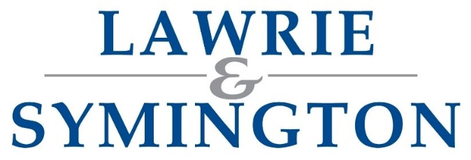 | SHOW & SALE OF SUFFOLK SHEEP  ENTRY FORM

SHOW & SALE: THURSDAY 17TH SEPTEMBER 2026
Vendor’s Trading Name: |  |  |  | Flock Name:
Address:
(inc. Postcode)
Contact Number:
Email:
Sort Code: |  |  | Account Number:
Holding Number (CPH): |  |  | UK Number:
Veterinary Attestation Number (V.A.N.): |  | If applicable/valid for ONE year
VAT receipt required for Entry Fees? |  |  | YES |  | NO
MV Accredited Status? |  |  | MV Acc

MALE (ALL CLASSES) – ENTRY FORM

Flock Code Year Individual Ear Tag Age Classification Semen Collected
1. |  |  | Ram / Shearling Ram  / Ram Lamb | Yes / No
NOTES:

Flock Code Year Individual Ear Tag Age Classification Semen Collected
2. |  |  | Ram / Shearling Ram  / Ram Lamb | Yes / No
NOTES:

Flock Code Year Individual Ear Tag Age Classification Semen Collected
3. |  |  | Ram / Shearling Ram  / Ram Lamb | Yes / No
NOTES:

Flock Code Year Individual Ear Tag Age Classification Semen Collected
4. |  |  | Ram / Shearling Ram  / Ram Lamb | Yes / No
NOTES:

Continued Overleaf /

SHOW & SALE OF SUFFOLK SHEEP

ENTRY FORM

Flock Code Year Individual Ear Tag Age Classification Semen Collected
5. |  |  | Ram / Shearling Ram  / Ram Lamb | Yes / No
NOTES:

Flock Code Year Individual Ear Tag Age Classification Semen Collected
6. |  |  | Ram / Shearling Ram  / Ram Lamb | Yes / No
NOTES:

Flock Code Year Individual Ear Tag Age Classification Semen Collected
7. |  |  | Ram / Shearling Ram  / Ram Lamb | Yes / No
NOTES:

Flock Code Year Individual Ear Tag Age Classification Semen Collected
8. |  |  | Ram / Shearling Ram  / Ram Lamb | Yes / No
NOTES:

Flock Code Year Individual Ear Tag Age Classification Semen Collected
9. |  |  | Ram / Shearling Ram  / Ram Lamb | Yes / No
NOTES:

Flock Code Year Individual Ear Tag Age Classification Semen Collected
10. |  |  | Ram / Shearling Ram  / Ram Lamb | Yes / No
NOTES:

(Further entries can be attached on separate sheet)

Final Entries close at strictly 12noon – per date highlighted in letter

Options to return Completed Forms (choose 1 option only):
Email: jenna@lawrieandsymington.com
Whatsapp: 07799845923
Postal: Lawrie & Symington Ltd, Lanark Agricultural Centre, Lanark, ML11 9AX

Entry Fee: as highlighted within letter (due at time of entry) Commission Rate: 5%

