Our Ref: AH/JWB

22nd July 2026

Dear Member/Breeder,

Please find enclosed entry form(s) ahead of this year’s Show & Sale of Suffolk Sheep. Details are timetabled below:
Sale: | Show & Sale of Suffolk Sheep
Show & Sale Dates: | Thursday 17th September 2026
Judges: | tbc
Sponsors: | tbc
Status of Sale: | MV Accredited and Non-Eligible for Export  (Arrivals are accepted evening before from approx. 6pm)
Closing Date: | Wednesday 19th August at strictly 12noon  (NO LATE ENTRIES WILL BE ACCEPTED)  Link to entry form: https://lawrieandsymington.com/entry-forms/
Entry Fee: | £12ph (£10+VAT) (Payable to Lawrie & Symington Ltd and MUST be paid with submission of Final Entries, otherwise entries will be withdrawn from  BACS Details – Sort Code 80-17-02 / Account – 00110611 (Ref Surname, Suffolk)
Pedigree Certificates: | Forward with entries if applicable
Substitutes: | Tuesday 15th September 2026 at strictly 12noon to Lanark Office  (List available online/day of sale)

Status of Entries: Females should be FULLY REGISTERED and Males should be Birth Notified prior to entry with Suffolk Sheep Society as the Grassroots function with be used to obtain your entries. This is your responsibility as the Vendor/Breeder of the animal. Failure to do so will incur immediate rejection.

Entries to be returned to the Lanark office or can be emailed to jenna@lawrieandsymington.com or Whatsapp to Jenna. No entries will be accepted over the phone.

MARTEYE: Online Bidding will be available, if potential buyers are not already registered, then they must do so prior to commencement of sale. Available to download via Google Play Store or App Store.

We thank you in anticipation of your entries, and if we can be of further assistance, then please do not hesitate to contact myself on 07917624409; Scott Ferrie 07557260653: Charlie Reid 07427970262; or Jenna Ballantyne on 07799845923.

Yours faithfully
For LAWRIE & SYMINGTON LIMITED
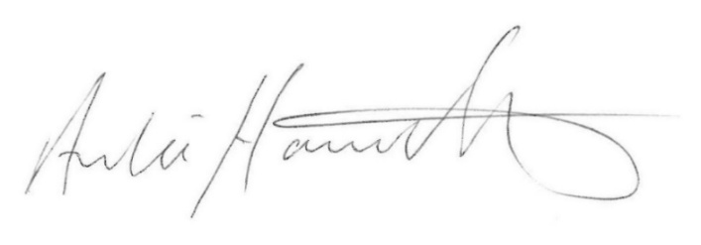
Archie Hamilton A.I.A. (Scot)
Head of Sheep Sales
Enc.

