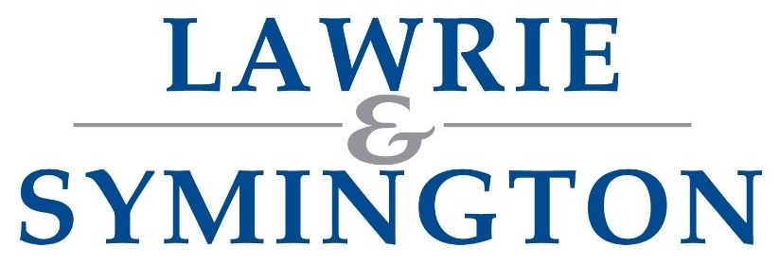 | Scottish Area Branch Show & Sale of Suffolk Sheep  Pre-Entry Form | 
SHOW & SALE ON BEHALF OF THE SCOTTISH AREA BRANCH OF THE SUFFOLK SHEEP SOCIETY

SHOW & SALE: THURSDAY 16TH JULY 2026
FLOCK NAME*:  (Example: Roadend) | (*Compulsory Information) | FLOCK CODE*:  (Example: BYM) | (*Compulsory Information)
CATEGORY OF STOCK |  | NUMBER OF ENTRIES
GIMMER (SHEARLING EWE)
(Max. 12 per Consignment)
EWE LAMB
(Max. 12 per Consignment)
SHEARLING RAM
(Max. 12 per Consignment)
RAM LAMB
(Max. 12 per Consignment)
SAB has the right to restrict numbers per vendor if excessive entries received
Receipt required for Entry Fees?  (UK: £25 per head / Outside UK: £50 per head) |  | YES | NO

VENDOR’S TRADING NAME:
ADDRESS (INC. POSTCODE):
CONTACT NUMBER:
EMAIL ADDRESS:
CPH (If applicable):
HERD/FLOCK NUMBER:
(UK XXXXXX)
VETERINARY ATTESTATION NUMBER (V.A.N.) | (If applicable/Valid for ONE year – NOT NAME OF VET PRACTISE)
SIGNATURE & DATE:

Pre-Entries and Final Entries close at 12noon – per date highlighted in letter

Options to return Completed Forms (choose 1 option only):
Email: jenna@lawrieandsymington.com
Whatsapp: 07799845923
Postal: Lawrie & Symington Ltd, Lanark Agricultural Centre, Lanark, ML11 9AX
Entry Fee: as highlighted within letter (due at time of submission of Pre-Entries) Commission Rate: 5%

