Our Ref: AH/JWB

20th May 2026

Dear Member/Breeder,

SHOW & SALE OF SUFFOLK SHEEP – THURSDAY 16TH JULY 2026
(On behalf of The Scottish Area Branch of the Suffolk Sheep Society)

Please find enclosed entry form(s) ahead of this year’s show & sale. Details/Code of Conduct etc are timetabled overleaf.

All Entries are to be returned to the Lanark office, emailed to jenna@lawrieandsymington.com or Whatsapp to Jenna on number below. (Full Entry Packs will be available once Pre-Entries are closed). No entries will be accepted over the phone. Entry Fees must accompany Pre-Entries to secure place in the ballot.
No Entry Fees – No Pre-Entries.

BIRTH NOTIFICATIONS AND FULL REGISTRATION: All males entered must be Birth Notified before submission of entries. All females entered must be fully registered before submission of entries. This is your responsibility as the vendor/breeder, failure to do so will incur immediate rejection of entry.

We thank you in anticipation of your entries, and if we can be of further assistance, then please do not hesitate to contact myself on 07917 624409; Scott Ferrie 07557 260653: Charlie Reid 07427 970262; or Jenna Ballantyne on 07799 845923.

Yours faithfully
For LAWRIE & SYMINGTON LIMITED
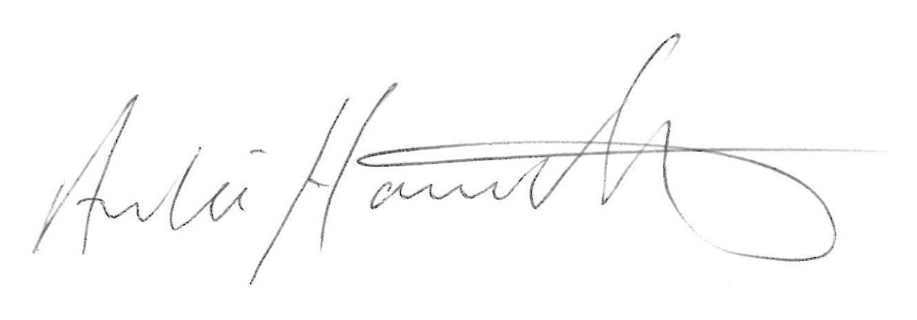
Archie Hamilton A.I.A. (Scot)
Head of Sheep Sales

Enc.
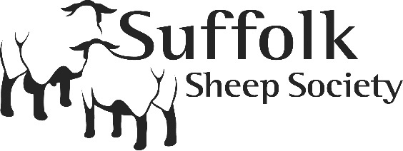 | 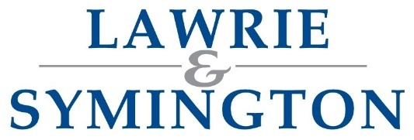 | 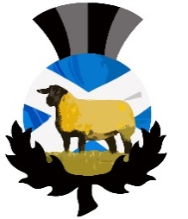
DETAILS OF SHOW & SALE and CODE OF CONDUCT
(as per The Scottish Area Branch of the Suffolk Sheep Society)

Sale | Show & Sale of Suffolk Sheep  (on behalf of The Scottish Area Branch of Suffolk Sheep Society)
Show & Sale Dates: | Thursday 16th July 2026: Show at 9am followed by Sale at 1.30pm
Judges: | - Pedigree: Mr Dafydd Jones, Frongoy flock  - Young Handlers & Elite Commercial Ram Lambs: Mr Andrew Currie, Quarter flock
Sponsors: | Galloway & MacLeod and Jamieson Bros
Status of Sale: | MV Accredited and Non-Eligible for Export
Scrapie Information: | 1) There is no requirement to Scrapie test this year through SRUC for entries. Please see attached information on the sale entry requirements for 2025 regarding voluntary testing  2) Consigners from NI/Ireland for Scrapie Monitored Flocks regarding Scrapie private tests.  If it is declared in the catalogue that sheep have been tested & are ARR/ARR, a certificate to verify results must be presented upon arrival showing these animals have been tested.
Arrival & Pre-Sale Inspection | Tuesday 14th July | Arrival of Stock (optional) – Time TBC
Arrival & Pre-Sale Inspection | Wednesday 15th July | Arrival of Stock – up until 2pm  Inspection (within pens) – 3pm  AGM – 5pm  Social Supper – 6.30pm
Pre-Entries Close: | Thursday 11th June at strictly 12noon (NO LATE ENTRIES WILL BE ACCEPTED)  Link to pre-entry form: https://lawrieandsymington.com/entry-forms/
Final Entries Close: | Opening: Friday 12th June (following Ballot)  Closing: Wednesday 24th June at 12noon (NO LATE ENTRIES WILL BE ACCEPTED)  Link to entry form: https://lawrieandsymington.com/entry-forms/  (Will be made available once Pre-Entries close and Entry Fees are received, No Fee – No Form)
Ballot: | To be drawn by The Scottish Area Branch of the Suffolk Sheep Society (James Wallace and Iain Barbour will attend) at Lawrie & Symington Ltd, Lanark Agricultural Centre  (Ballot Date: Friday 12th June at 11am approx.)
Entry Fee (UK Consigners): | £25.00 per head, non-refundable  (Payable to Lawrie & Symington Ltd & MUST be paid by submission of Pre-Entries, otherwise entries will be withdrawn from Ballot)  BACS Details: Sort Code 80-17-02 / Account: 00110611 (Ref Surname, Suffolk)
Outside of UK Entries: | If Suffolk Sheep Society allows entries from out with UK, consigners are reminded the entry fee is £50 per sheep with a maximum of three per vendor per category as per Scottish Branch Committee. (Payment details as per above point apply)
Lot Numbering: | All sheep to be clearly back stamped with allocated lot numbers  As per By Law 16.13.3: all sheep must be marked with their catalogue number prior to arrival at the sale using Red Marker Ink, sheep marked with any other colour risk being rejected at inspection – per Suffolk Sheep Society Council (December 2023)
Substitutes: | Friday 10th July to Lanark Office by 12noon (max. 2 per consigner)  To be clearly marked on loin with Red Dot
Society Membership: | ‘Suffolk Sheep Society Ltd’ Member

CODE OF CONDUCT AT SCOTTISH AREA BRANCH SALES (AS PER SCOTTISH AREA BRANCH COMMITTEE):
- The agreement by Council states that Inspectors and Veterinary Surgeons on all such matters shall be final and binding verbal abuse intimidation and attempted harassment will not be tolerated.
- Any of the above actions by members will be reported to Council and may be put in front of Disputes and Disciplinary committee to reach an outcome on the case.
- Scrapie Health Certificate are requested for sheep coming from Northern Ireland on arrival at the Market on the sale day along with MV certificates.
- Please remember no Excessive Black Wool / or Excessive Wool Peelers are permitted at the sale.

